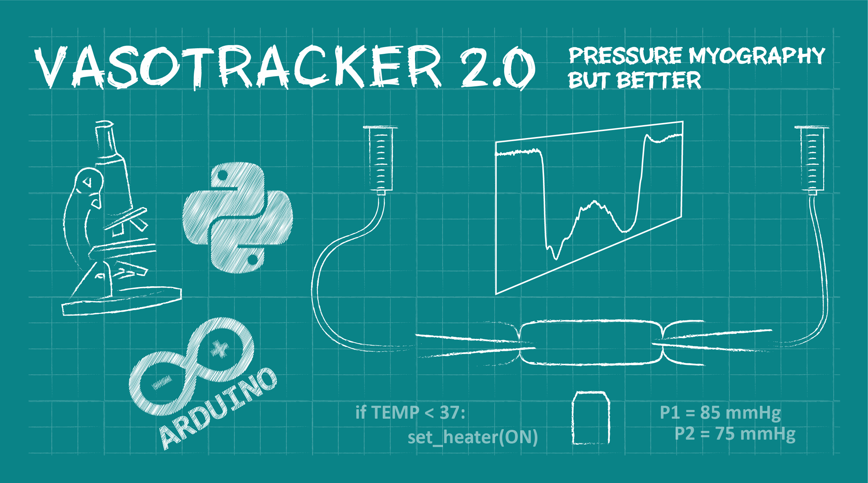

**V2.0**

**Data Acquisition & Analysis Software**

**User Manual**

**16/04/2024**

**Developed at the University of Strathclyde**

**Email Calum if you need help.**

|  |  |  |  |  |
| --- | --- | --- | --- | --- |
|  |  |  |  | www.vasotracker.com |

Table of Contents

1. Overview 2

VasoTracker

Citing VasoTracker

1. Installation 3

Hardware requirements

Supported cameras

Installation prerequisites

Installing VasoTracker

1. Running VasoTracker 6

Setting up a VasoTracker shortcut

Maximizing VasoTracker performance

Starting the VasoTracker Data Acquisition Software

1. VasoTracker Settings 9

The settings bar

Source control panel

Acquisition Settings control panel

Analysis Settings control panel

Outer and Inner Diameter Graph Settings control panel

Data Acquisition panel

Start/Stop panel

Image dimension panel

Caliper panel

Pressure settings panel

Pressure protocol panel

1. VasoTracker Data Export 15

Data export

Data entry table

1. Editing VasoTracker 16

# Overview

VasoTracker is an open source pressure myograph system for tracking the diameter of isolated, pressurized blood vessels. The complete system includes a vessel chamber, temperature controller, pressure monitor, microscope, camera, laptop computer, and analysis software – everything that is required to perform pressure myography.

We made VasoTracker because we wanted to make pressure myography more accessible (i.e. cheaper) and customizable. The full system costs ~$4500 (£3500 if you are in the UK). This is ~10% of the cost of a commercial myograph system. Visit the VasoTracker website ([www.vasotracker.com](http://www.vasotracker.com)) to find out how to build your own.

## Citing VasoTracker

Our ability to support, develop and maintain VasoTracker depends on external grant funding, so whether you use the VasoTracker software and hardware as a complete system or only certain bits, please cite VasoTracker in your scientific publications.

**VasoTracker 2.X**

Matthew D. Lee, Nathan Tykocki, Charlotte Buckley, Xun Zhang, Cian Woodsend, John G. McCarron and Calum Wilson (2019). VasoTracker 2.0 – Open Source Pressure Myography Hardware and Software for Blood Vessel Diameter Measurement. *In Production.*

## Fully Supported cameras

VasoTracker utilizes camera libraries provided by Micro-Manager (µManager) Open Source Microscopy Software (<https://micro-manager.org/>). If your camera works in µManager, then it should work with VasoTracker. We have fully tested, and use the following cameras:

* Basler Ace 2 camera (a2A1920-160um)
* Thorlabs CS165MU/M
* Thorlabs DCC1545M USB 2.0 Camera
* OpenCV cameras

## Other cameras

If your camera works in µManager, then it should work with **VasoTracker 2.0**.

## Offline analysis

VasoTracker 2.0 can analyze prerecorded data files.

# Installation

## Hardware requirements

|  |  |
| --- | --- |
|  | **VasoTracker is only compatible with 64-bit Windows operating systems.**  (well, we have only tested it on 64-bit operating systems) |

* Microsoft Windows 10 64-bit
* 8GB RAM minimum (preferably 16GB)
* Compatible USB camera (see below)

## Prerequisites

1. **Install uManager:**

* Visit the [µManager Downloads Page](https://micro-manager.org/wiki/Download_Micro-Manager_Latest_Release) and download the **latest nightly build** of µManager for your operating system.
* Follow the provided instructions to install µManager on your computer.

## Steps

1. **Download the latest VasoTracker release:**

* Visit the VasoTracker Releases Page and download the latest zip file for your operating system.

1. **Extract the Zip File:**

* Locate the downloaded zip file on your computer.
* Right-click the file and select "Extract All..." or use your preferred extraction software.
* Choose a destination folder to extract the files and confirm the action.

1. **Run VasoTracker 2.0**

* Navigate to the extracted folder.
* Double-click the executable file to start the application.

# Running from Source Code or Editing VasoTracker

VasoTracker is written entirely in the Python programming language. Anyone may edit it in any way they see fit.

[Full details for source code installation are on the VasoTracker 2.0 GitHub Repository](https://github.com/VasoTracker/VasoTracker-2)

# Camera & System Setup

## Basler Cameras

1. **Basler Ace 2 (**[**a2A1920-160umBAS**](https://www.baslerweb.com/en/shop/a2a1920-160umbas/)**)**

* Download and Install [Basler Pylon 7.1](https://www2.baslerweb.com/en/downloads/software-downloads/software-pylon-7-1-0-windows/)
* Configure uManager to use the camera and save the configuration file as “Basler.cfg”
* Replace the configuration file in the VasoTracker installation directory (this is mandatory, as VasoTracker must know the serial number of your camera).

## Thorlabs Cameras

1. **Zelux CMOS Camera (**[**CS165MU/M**](https://www.thorlabs.com/thorproduct.cfm?partnumber=CS165MU/M)**)**

* Download and Install [Thorcam 3.7.0](https://www.thorlabs.com/software_pages/viewsoftwarepage.cfm?code=ThorCam)
* Follow the instructions on the [µManager Thorlabs Scientific Imaging Cameras driver webpage](https://micro-manager.org/TSI) (copying/pasting files is required here).
* If installed correctly and working in µManager, VasoTracker will automatically connect when the camera is selected.

1. **[Obsolete] CMOS Camera (**[**DCC1545M**](https://www.thorlabs.com/thorproduct.cfm?partnumber=DCC1545M)**)**

* Download and Install [Thorcam 3.7.0](https://www.thorlabs.com/software_pages/viewsoftwarepage.cfm?code=ThorCam)
* Follow the instructions on the [µManager Thorlabs Scientific Imaging Cameras driver webpage](https://micro-manager.org/TSI) (copying/pasting files is required here).

## Any other µManager compatible camera

1. Download and install any required software/drivers.
2. Set up the camera in µManager
3. Create aµManager System Configuration with Startup and Shutdown Presets to set any specific settings required by your camera (VasoTracker will only control the exposure) - [**Follow the instructions here**](https://micro-manager.org/Micro-Manager_Configuration_Guide#:~:text=trans%2Dillumination%20shutter.-,Startup%20Presets,shutdown%20of%20Micro%2DManager%20respectively.)
4. Save your configuration file as “MMConfig.cfg”
5. Replace the configuration file in the VasoTracker Installation directory (VasoTracker will not be able to control your camera if you fail to do this).

# Temperature & Pressure Monitor Setup

* Download and install the Arduino IDE from the Aduino website:

<https://www.arduino.cc/download_handler.php?f=/arduino-1.8.8-windows.exe>

* From v1.3.0: Download and install the NI-DAQmax drivers from the National Instruments website: <https://www.ni.com/en-gb/support/downloads/drivers/download.ni-daqmx.html#348669>

# Running VasoTracker

|  |  |
| --- | --- |
|  | **VasoTracker may have been updated since this section was written.**  If it has, we should be updating these instructions soon. If you have any queries,  send an email to vasotracker@gmail.com. |

## Setting up a VasoTracker shortcut

To set up a desktop shortcut:

* Navigate to the VasoTracker installation folder on your computer.
* Right click on the VasoTracker.exe
* Click “Send to”
* Click “Desktop”
* This action creates a desktop shortcut to the file or folder on your desktop.
* VasoTracker will run in administrator mode (this ensures VasoTracker can save data files wherever you specify).

## Maximizing VasoTracker performance

We run VasoTracker on a number of different computer systems, on our less-able computers the following actions help performance:

* [Using the “High Performance” Windows 10 power plan](https://help.ableton.com/hc/en-us/articles/115000211304-How-to-disable-power-throttling-on-Windows)
* [Disabling Windows USB selective suspend](https://www.windowscentral.com/how-prevent-windows-10-turning-usb-devices%3famp)
* [Preventing Windows shutting off power to USB root hub](https://www.eposaudio.com/en/gb/support/knowledge-base/faqs/frequently-asked-questions/enabling-or-disabling-power-save-option-for-usb-ports-in-windows-10#:~:text=Click%20on%20the%20tab%20labeled,the%20bottom%20of%20the%20window.)

## Starting the VasoTracker Data Acquisition Software

VasoTracker can be launched by any of the following methods:

* Double-clicking the desktop shortcut (created above).
* Double-clicking VasoTracker.exe in the installation folder
* Running VasoTracker.py from the python command line.

Upon launching, the VasoTracker software will prompt the user to create a .csv file for saving data. A “Save As” dialogue box will appear. The file name field is automatically populated with the current date in the default “Results” folder. However, the user may change the folder location and the filename.

|  |  |
| --- | --- |
|  | **If a csv file with the same name already exists, a warning will pop up and the user will be asked to confirm whether the existing file is to be replace. Selecting “Yes” will erase all data in the original file!** |

Once a save file has been created, VasoTracker will then launch with the default settings and you will be presented with the layout shown below.

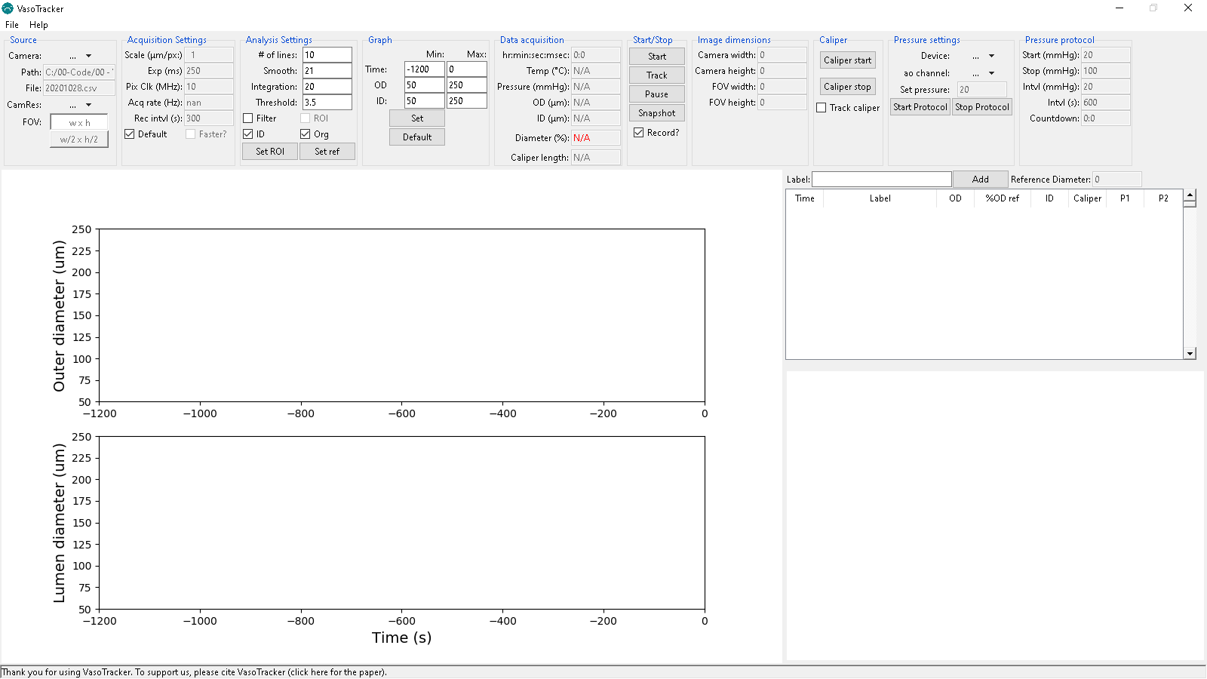

**Figure 1 – VasoTracker start screen**

### Demo Camera Mode

To familiarize users with the VasoTracker Data Acquisition Software, VasoTracker comes bundled with a fake/virtual camera adapter. This virtual camera adapter loads an example video recording of a pressurized artery and displays data as if a real camera is connected.

To run VasoTracker in Demo Mode:

* Enable the Virtual Camera by select “FakeCamera” in the “Source” panel.
* Start the virtual image acquisition by clicking “Start” in the “Start/Stop” panel.
* Begin diameter tracking by clicking “Track” in the “Start/Stop” panel.
* Once diameter tracking has initiated, diameter indicators will be overlaid on the camera feed box (Figure 2) and both inner and outer diameter will be plotted on the live graphs.

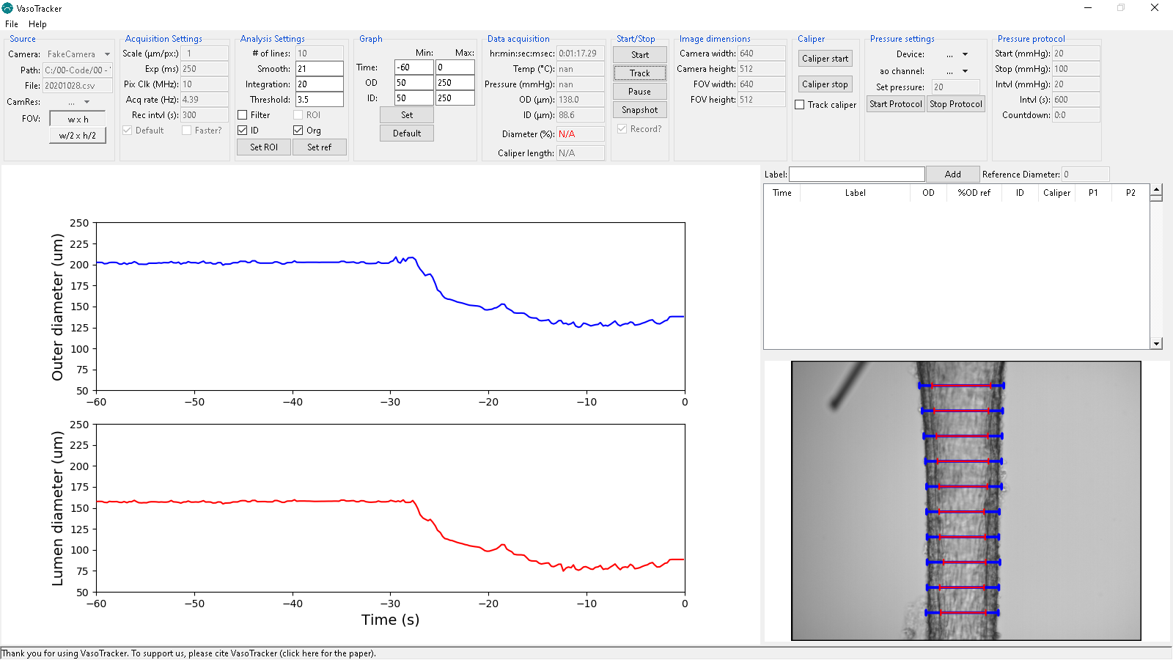

**Figure 3 – Virtual Camera Mode with diameter tracking**

### Live Camera Mode

To run VasoTracker in live mode (i.e. acquiring images from a real camera)

* Load your camera by select “Thorlabs” or other camera driver in the “Source” panel.
* Start the image acquisition by clicking “Start” in the “Start/Stop” panel.
* Begin diameter tracking by clicking “Record” in the “Start/Stop” panel.

# VasoTracker Settings

|  |  |
| --- | --- |
|  | **VasoTracker may have been updated since this section was written.**  If it has, we should be updating these instructions soon. If you have any queries,  send an email to vasotracker@gmail.com. |

## The settings bar

All of the acquisition and analysis settings can be altered in the settings bar. The settings bar also displays some handy information. Default settings can be changed by editing “default_settings.ini” in the root folder.



**Figure 4 – VasoTracker settings bar**

## Source control panel



**Figure 5 – Source settingsCamera:** Select your camera here. If you are using a non-standard camera (you must have a working µManager config file), select µManagerCam. To use µManagerCam you mist place your µManager config file in the VasoTracker installation folder.

**Path:** displays the path to the current working directory.

**File:** displays the output file name.

**FOV:** buttons to set the field-of-view. This will only work for some cameras.

## Acquisition Settings control panel



**Figure 6 – Acquisition settingsDefault:** Enable/disable the default acquisition settings

**Faster?:** Enable/disable faster data acquisition here. This is still experimental.

**Scale:** Set the image calibration here. The default value of one will output diameter value in pixel units.

**Exp:** Set the camera exposure here.

**Pix Clk:** set the camera pixel clock here. Only for the Thorlabs camera. It allows more control over the exposure and frame rate.

**Acq rate:** displays the current acquisition rate.

**Rec intvl:** Set the interval (in seconds) for exporting images here.

## Analysis Settings control panel



**Figure 7 – Analysis settings# of lines:** Set the number of scan lines here.

**Smooth:** Set how much smoothing is applied to intensity profiles (will improve wall detection).

**Integration:** Set the number of pixel lines over which diameter is integrated.

**Threshold:** Set threshold value for identifying outliers

**Filter:** Enable/disable outlier filtering

**ROI:** Enable/disable the ROI function.

**ID:** enable/disable inner diameter detection

**Org:** Slight modification of the tracking algorithm

**Set ROI:** Click here to draw an ROI on the display feed, diameter measurement will be limited to this ROI.

**Set ref:** Click here to set the current diameter as a reference value

|  |  |
| --- | --- |
|  | **When editing settings, you must confirm the values entered by hitting the “Enter” button on your keyboard.** |

## Outer and Inner Diameter Graph Settings control panel



**Figure 8 – Graph settingsTime:** Set the x-axis (time) limits

**OD:** Set the outer diameter axis limits.

**ID:** Set the inner diameter axis limits.

**Set:** Click here to allow an ROI to be drawn on the display feed, diameter measurement will be limited to this ROI.

**Default:** Click here to set the corresponding graph limits to default values.

|  |  |
| --- | --- |
|  | **All changes to graph settings must be confirmed by hitting the “Enter” button on your keyboard.** |

## Data Acquisition panel



**Figure 9 – Data displayTime:** Displays the elapsed time (zeroed at beginning of experiment.

**Temp:** Displays the current temperature (from VasoTracker temperature controller).

**Avg Pressure:** Displays the vessel pressure (average of readings from VasoTracker pressure sensor).

**Outer diameter:** Displays the current inner diameter.

**Inner diameter:** Displays the current inner diameter.

**Diameter:** Displays the current (outer) diameter as a percentage of the reference diameter.

**Caliper length:** Displays the length of the manual caliper if drawn.

## Start/Stop panel



**Figure 10 – Start/stop panelStart:** Starts image acquisition.

**Track:** Starts the diameter tracking function.

**Pause:** Pauses diameter tracking (this enables settings to be altered).

**Snapshot:** Saves a snapshot of the current image display (with and without diameter indicators).

**Record?:** Enables/disables saving the image feed.

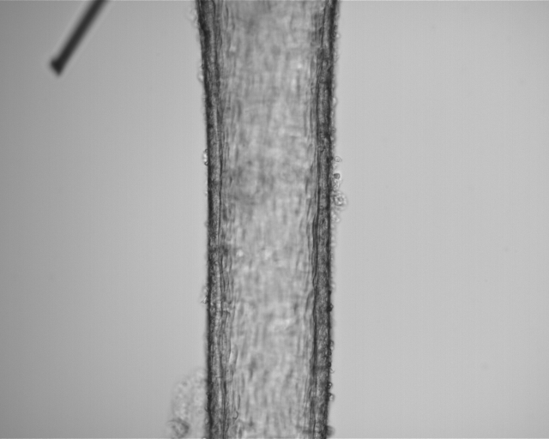 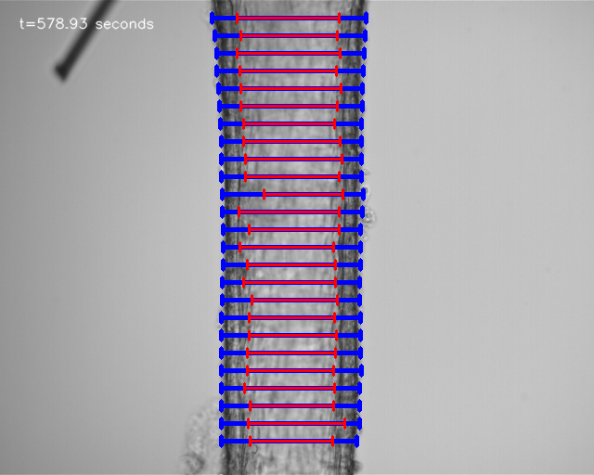

**Figure 11 – Example saved images without (middle) and with (right)diameter indicators overlaid.**

## Image dimension panel



**Figure 12 – Image dimensions**

**Camera width:** Displays the width (in pixels) of the camera chip.

**Camera height:** Displays the height (in pixels) of the camera chip.

**FOV width:** Displays the width (in pixels) of the current field-of-view.

**FOV height:** Displays the height (in pixels) of the current field-of-view.

## Caliper panel



**Figure 12 – Caliper**

**Caliper start:** pauses image acquisition so that a manual caliper can be drawn on the image

**Caliper stop:** Does nothing at the moment.

**Track caliper:** Track diameter across the length of the caliper.

## Pressure settings panel



**Figure 12 – Pressure settings**

**Device:** National Instrument device ID

**ao channel:** Analogue out channel for NI device

**Set pressure:** Desired pressure for servo control

**Start Protocol:** Starts the pressure protocol defined in “default_settings.ini”

**Stop Protocol:** Stops the pressure protocol defined in “default_settings.ini”

## Pressure protocol panel



**Figure 12 – Image dimensions**

**Start (mmHg):** Start pressure for protocol

**Stop (mmHg):** End pressure for protocol

**Intvl (mmHg):** Desired pressure step

**Intvl (s):** Desired time interval

**Countdown:** The time left until the next pressure step.

# VasoTracker Data Export

## Data export

All data is saved automatically. On launching VasoTracker, the user is asked to create a .csv file. At each time point, all experimental parameters (time, average, diameter, pressure, temperature, etc.) are appended to the CSV file.

**Individual scanline measurements:**

The outer and inner diameter measurements of all scan lines are saved in separate CSV files (“…profiles.csv”).

**Spurious measurements:**

Whether or not the filtering algorithm is active, all scanline measurement are checked for spurious results. Indicators are saved in the “Flags.csvfiles. ” (1 indicates a good measurement, 0 indicates a spurious measurement). If the filtering algorithm is activated, spurious measurements are not included in the average calculations.

## Data entry table

VasoTracker also includes a data entry table (Figure 13). The table allows the user to enter details of any experimental manipulations and provides a convenient measure of arterial tone at the time of each entry. Any data entered into the Data Entry Table (See below) is saved as an additional .csv file, “…tables.csv”.

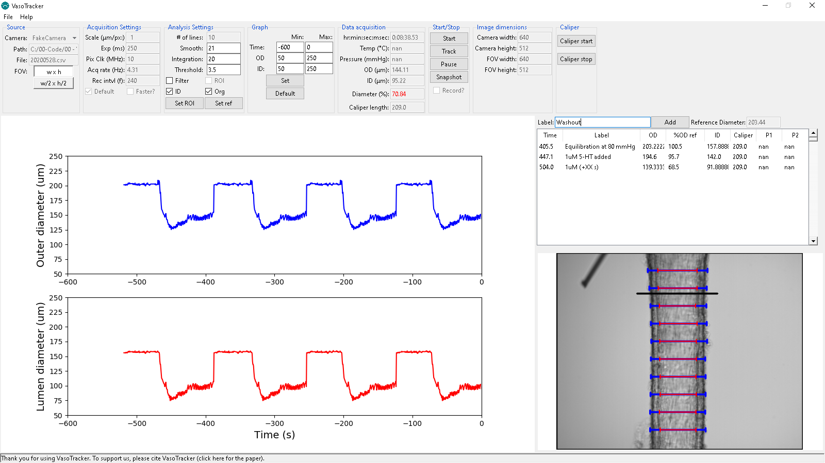

**Figure 13 – Data entry table**

# Editing VasoTracker

VasoTracker is written entirely in the Python programming language. Anybody can edit it in any way they see fit.

|  |
| --- |
| www.vasotracker.com |